**CloudVandana Coding Assignment**

**JAVA**

**1. Create an array with the values (1, 2, 3, 4, 5, 6, 7) and shuffle it.**

import java.util.Random;

public class ShuffleArray {

public static void main(String[] args) {

int[] array = {1, 2, 3, 4, 5, 6, 7};

shuffleArray(array);

for (int number : array) {

System.out.print(number + " ");

}

}

public static void shuffleArray(int[] array) {

Random random = new Random();

for (int i = array.length - 1; i > 0; i--) {

int j = random.nextInt(i + 1);

// Swap array[i] and array[j]

int temp = array[i];

array[i] = array[j];

array[j] = temp;

}

}

}

**2. Enter Roman Number as input and convert it to integer. (ex IX = 9)**

import java.util.Scanner;

public class IntegerToRoman {

public static void main(String[] args) {

Scanner scanner = new Scanner(System.in);

System.out.print("Enter an integer: ");

int number = scanner.nextInt();

if (number < 1 || number > 3999) {

System.out.println("Number out of valid range1 to 3999.");

} else {

String romanNumeral = intToRoman(number);

System.out.println("Roman numeral: " + romanNumeral);

}

}

public static String intToRoman(int num) {

int[] values = {1000, 900, 500, 400, 100, 90, 50, 40, 10, 9, 5, 4, 1};

String[] symbols = {"M", "CM", "D", "CD", "C", "XC", "L", "XL", "X", "IX", "V", "IV", "I"};

StringBuilder roman = new StringBuilder();

for (int i = 0; i < values.length; i++) {

while (num >= values[i]) {

roman.append(symbols[i]);

num -= values[i];

}

}

return roman.toString();

}

}

**3. Check if the input is pangram or not. (Pangram is a sentence that contains all the alphabets from a-z)**

import java.util.Scanner;

public class PangramCheck {

public static void main(String[] args) {

Scanner scanner = new Scanner(System.in);

System.out.print("Enter Value: ");

String input = scanner.nextLine().toLowerCase();

boolean isPangram = checkPangram(input);

if (isPangram) {

System.out.println("The input is a pangram.");

} else {

System.out.println("The input is not a pangram.");

}

}

public static boolean checkPangram(String input) {

for (char letter = 'a'; letter <= 'z'; letter ++) {

if (input.indexOf(letter) == -1) {

return false;

}

}

return true;

}

}

**JavaScript**

**1. Take a sentence as an input and reverse every word in that sentence.**

**Example - This is a sunny day > shiT si a ynnus yad.**

function reverseWords(sentence) {

const words = sentence.split(' ');

const reversedWords = words.map(word => reverseWord(word));

const reversed = reversedWords.join(' ');

return reversed;

}

function reverseWord(word) {

return word.split('').reverse().join('');

}

const inputSentence = **"This is a sunny day";**

const reversedSentence = reverseWords(inputSentence);

console.log(reversedSentence); **// Output: "sihT si a ynnus yad"**

**2. Perform sorting of an array in descending order.**

function sortDescending(arr) {

for (let i = 0; i < arr.length; i++) {

for (let j = 0; j < arr.length - 1 - i; j++) {

if (arr[j] < arr[j + 1]) {

const temp = arr[j];

arr[j] = arr[j + 1];

arr[j + 1] = temp;

}

}

}

}

const numbers = **[5, 2, 9, 1, 5, 6];**

sortDescending(numbers);

console.log(numbers); **// Output: [9, 6, 5, 5, 2, 1]**

**HTML**

**1. Create a basic calculator using HTML, CSS, and Javascript with the functionality of add,**

**subtract, multiply and divide. Use the following picture for reference.**

**We have three file   
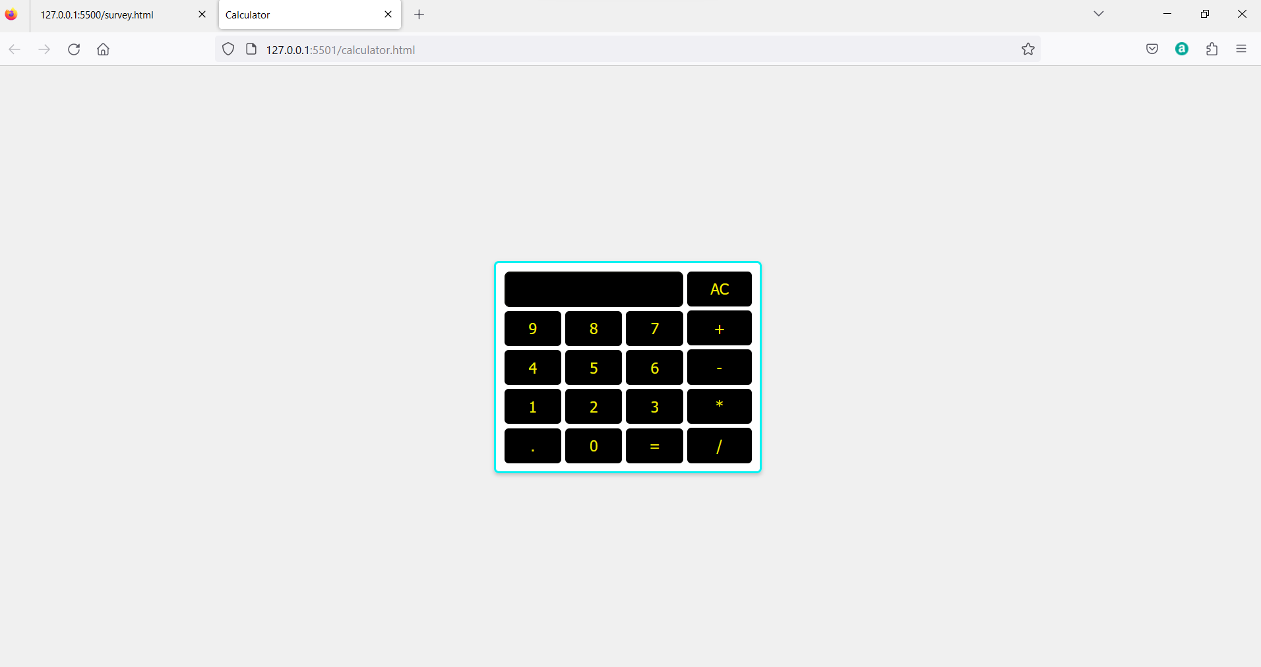  
  
1=> calculator.html**

**<!DOCTYPE html>**

**<html lang="en">**

**<head>**

**<meta charset="UTF-8">**

**<meta name="viewport" content="width=device-width, initial-scale=1.0">**

**<link rel="stylesheet" type="text/css" href="calculator.css">**

**<title>Calculator</title>**

**</head>**

**<body>**

**<body>**

**<div class="cal">**

**<div class="calculator">**

**<input type="text" id="display" disabled>**

**<div class="buttons1">**

**<button onclick="appendToDisplay('9')">9</button>**

**<button onclick="appendToDisplay('8')">8</button>**

**<button onclick="appendToDisplay('7')">7</button>**

**<button onclick="appendToDisplay('4')">4</button>**

**<button onclick="appendToDisplay('5')">5</button>**

**<button onclick="appendToDisplay('6')">6</button>**

**<button onclick="appendToDisplay('1')">1</button>**

**<button onclick="appendToDisplay('2')">2</button>**

**<button onclick="appendToDisplay('3')">3</button>**

**<button onclick="appendToDisplay('.')">.</button>**

**<button onclick="appendToDisplay('0')">0</button>**

**<button onclick="calculate()">=</button>**

**</div>**

**</div>**

**<div class="buttons2">**

**<button onclick="clearDisplay()">AC</button>**

**<button onclick="appendToDisplay('+')">+</button>**

**<button onclick="appendToDisplay('-')">-</button>**

**<button onclick="appendToDisplay('*')">*</button>**

**<button onclick="appendToDisplay('/')">/</button>**

**</div>**

**</div>**

**<script src="calculator.js"></script>**

**</body>**

**</html>**

**2=> Calculator.css**

**body {**

**display: flex;**

**justify-content: center;**

**align-items: center;**

**height: 100vh;**

**margin: 0;**

**background-color: #f0f0f0;**

**}**

**.cal {**

**display: flex;**

**gap: 5px;**

**background-color: #fff;**

**border: 3px solid #05f1f1;**

**border-radius: 5px;**

**box-shadow: 0 2px 5px rgba(0, 0, 0, 0.2);**

**padding: 10px;**

**width: 300px;**

**}**

**#display {**

**width: 94%;**

**height: 30px;**

**border: 2px solid #0a0a06f9;**

**background-color: #000;**

**font-size: 20px;**

**color: #f5f102f9;**

**border-radius: 7px;**

**text-align: right;**

**padding: 5px;**

**margin-bottom: 5px;**

**}**

**.buttons {**

**display: grid;**

**grid-template-columns: repeat(2, 1fr);**

**gap: 10px;**

**}**

**.buttons1 {**

**width: 100%;**

**display: grid;**

**grid-template-columns: repeat(3, 1fr);**

**gap: 5px;**

**}**

**.buttons2 {**

**width: 30%;**

**display: grid;**

**gap: 5px;**

**}**

**button {**

**font-size: 18px;**

**padding: 10px;**

**text-align: center;**

**background-color: #000;**

**color: #f5f102f9;**

**border: none;**

**border-radius: 5px;**

**cursor: pointer;**

**transition: background-color 0.2s;**

**}**

**button:hover {**

**background-color: #071441;**

**}**

**3=> calculator.js**

**let currentInput = "";**

**let calculation = "";**

**function appendToDisplay(value) {**

**currentInput += value;**

**document.getElementById("display").value = currentInput;**

**}**

**function clearDisplay() {**

**currentInput = "";**

**document.getElementById("display").value = currentInput;**

**}**

**function calculate() {**

**try {**

**const result = eval(currentInput);**

**document.getElementById("display").value = result;**

**currentInput = result;**

**} catch (error) {**

**document.getElementById("display").value = "Error";**

**currentInput = "";**

**}**

**}**

**2. Create a survey form with Fields like First Name, Last Name, Date of Birth, Country**

**(dropdown), Gender (checkbox), Profession, email, and mobile number. All the input**

**fields are necessary to submit the form. Create two buttons Submit and Reset. Reset will**

**reset the form while on clicking on submit, first it will check all the fields and necessary**

**validations and then a popup will appear displaying all the selected values with label in front of it.**

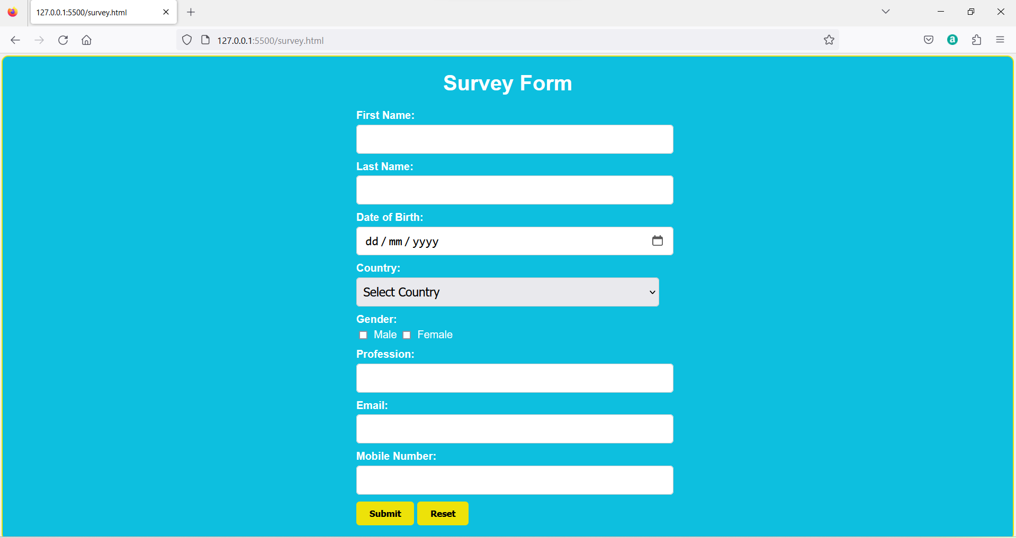

**1=>survey.html  
  
<!DOCTYPE html>**

**<html>**

**<head>**

**<link rel="stylesheet" type="text/css" href="survey.css" />**

**</head>**

**<body>**

**<div class="container">**

**<h1>Survey Form</h1>**

**<form id="surveyForm">**

**<div class="form-group">**

**<label for="firstName">First Name:</label>**

**<input type="text" id="firstName" required />**

**</div>**

**<div class="form-group">**

**<label for="lastName">Last Name:</label>**

**<input type="text" id="lastName" required />**

**</div>**

**<div class="form-group">**

**<label for="dob">Date of Birth:</label>**

**<input type="date" id="dob" required />**

**</div>**

**<div class="form-group">**

**<label for="country">Country:</label>**

**<select id="country" required>**

**<option value="">Select Country</option>**

**<option value="India">India</option>**

**<option value="USA">USA</option>**

**<option value="Canada">Canada</option>**

**<option value="UK">UK</option>**

**<option value="Other">Other</option>**

**</select>**

**</div>**

**<div class="form-group">**

**<label>Gender:</label>**

**<input type="checkbox" id="male" name="gender" value="Male" /> Male**

**<input type="checkbox" id="female" name="gender" value="Female" />**

**Female**

**</div>**

**<div class="form-group">**

**<label for="profession">Profession:</label>**

**<input type="text" id="profession" required />**

**</div>**

**<div class="form-group">**

**<label for="email">Email:</label>**

**<input type="email" id="email" required />**

**</div>**

**<div class="form-group">**

**<label for="mobile">Mobile Number:</label>**

**<input type="tel" id="mobile" required />**

**</div>**

**<div class="form-group">**

**<button type="submit" onclick="submitForm()">Submit</button>**

**<button type="button" onclick="resetForm()">Reset</button>**

**</div>**

**</form>**

**</div>**

**<script src="survey.js"></script>**

**</body>**

**</html>**

**2=>survey.css**

**body {**

**font-family: Arial, sans-serif;**

**background-color: #f0f0f0;**

**margin: 0;**

**padding: 0;**

**display: flex;**

**justify-content: center;**

**align-items: center;**

**}**

**.container {**

**background-color: #0dbfdf;**

**border: 2px solid #ede209;**

**border-radius: 10px;**

**box-shadow: 2 5px 5px rgba(46, 45, 45, 0.2);**

**width: 100vw;**

**height: 100vh;**

**margin: 3px;**

**padding: 0%;**

**color: #fff;**

**}**

**h1 {**

**text-align: center;**

**}**

**.form-group {**

**margin-bottom: 15px;**

**margin: auto;**

**margin-bottom: 10px;**

**width: 30%;**

**}**

**label {**

**display: block;**

**margin-bottom: 5px;**

**font-weight: bold;**

**}**

**input[type="text"],**

**input[type="date"],**

**select,**

**input[type="email"],**

**input[type="tel"] {**

**width: 100%;**

**padding: 10px;**

**font-size: 18px;**

**border: 1px solid #ccc;**

**border-radius: 5px;**

**}**

**input[type="checkbox"] {**

**margin-right: 5px;**

**}**

**button {**

**background-color: #ede209;**

**color: #000;**

**border: none;**

**font-weight: 600;**

**border-radius: 5px;**

**padding: 10px 20px;**

**cursor: pointer;**

**transition: background-color 0.2s;**

**}**

**button:hover {**

**background-color: #d7ff0c;**

**color: #242222;**

**}**

**.close {**

**color: #aaa;**

**float: right;**

**font-size: 30px;**

**font-weight: bold;**

**cursor: pointer;**

**}**

**.close:hover {**

**color: #000;**

**}**

**#summary {**

**padding: 10px;**

**}**

**3=>survey.js  
  
function submitForm() {**

**const firstName = document.getElementById("firstName").value;**

**const lastName = document.getElementById("lastName").value;**

**const dob = document.getElementById("dob").value;**

**const country = document.getElementById("country").value;**

**const genderMale = document.getElementById("male").checked;**

**const genderFemale = document.getElementById("female").checked;**

**const profession = document.getElementById("profession").value;**

**const email = document.getElementById("email").value;**

**const mobile = document.getElementById("mobile").value;**

**const errors = [];**

**if (!firstName.match(/^[A-Za-z]+$/)) {**

**errors.push("First Name should contain only alphabetic characters.");**

**}**

**if (!lastName.match(/^[A-Za-z]+$/)) {**

**errors.push("Last Name should contain only alphabetic characters.");**

**}**

**if (!dob) {**

**errors.push("Please enter a valid Date of Birth.");**

**}**

**if (!country) {**

**errors.push("Please select a Country.");**

**}**

**if (!genderMale && !genderFemale) {**

**errors.push("Please select a Gender.");**

**}**

**if (!profession) {**

**errors.push("Please enter your Profession.");**

**}**

**if (!email.match(/^[\w-]+(\.[\w-]+)*@[\w-]+(\.[\w-]+)+$/)) {**

**errors.push("Please enter a valid Email address.");**

**}**

**if (!mobile.match(/^\d{10}$/)) {**

**errors.push("Mobile Number should contain 10 digits.");**

**}**

**if (errors.length > 0) {**

**alert(errors.join("\n"));**

**} else {**

**const formData = `**

**First Name: ${firstName}**

**Last Name: ${lastName}**

**Date of Birth: ${dob}**

**Country: ${country}**

**Gender: ${genderMale ? "Male" : "Female"}**

**Profession: ${profession}**

**Email: ${email}**

**Mobile Number: ${mobile}**

**`;**

**alert("Form Data:\n\n" + formData);**

**}**

**}**

**function resetForm() {**

**const form = document.getElementById("surveyForm");**

**form.reset();**

**}**